Batch: Roll No.:

Experiment / assignment / tutorial No. 1

Grade: AA / AB / BB / BC / CC / CD /DD

Signature of the Staff In-charge with date

Title: : Implementation of Database in SQL -DDL

Objective: Define/modify database definitions with proper constraints
_____________________________________________________________
Expected Outcome of Experiment:
CO 2: Convert entity-relationship diagrams into relational tables, populate a relational
database and formulate SQL queries on the data Use SQL for creation and query the database.

CO 3: Define and apply integrity constraints and improve database design using normalization techniques.
_______________________________________________________________________
Pre Lab/ Prior Concepts:
Resources used: Postgresql

Theory: The set of relations in a database must be specifies to the system by means of a data definition language (DDL). The SQL DDL allows specification of not only a set of relations but also specific information about the relation including,
- The schema for each relation
- The domain of values associated with each attribute
- The integrity constraints
- The set of indices to be maintained for each relation
- The security and authorization information for each relation
- The physical storage structure of each relation on disk

Syntax Create Table:
create table employee(ssn,fname varchar(10), mname varchar(10), lname varchar(10), desg varchar(20), gender varchar(5), addr varchar(20), bdate datetime, sal float,primary key(ssn));
create table manages(ssn int, dept_code int, start_dt datetime, foreign key(ssn) references employee, foreign key(dept_code) references department, key(ssn,dept_code) ) on delete set null

Data Constraints
Business managers of the organization determine a set of rules that must be applied before the data is stored in the database. The application of such rules on raw data ensures data integrity.
Eg:- An employee belonging to the Sales department cannot have a salary higher than Rs. 1000.
An employee has an unique identification number.
Applying Data Constraints
Oracle permits data constraints to be attached to table columns using SQL syntax. Constraints can be attached to table columns using Alter table.
Unique Constraint
Unique Constraint- At column level Syntax
<ColumnName><Datatype>(<size>) UNIQUE
Unique Constraint- At table level
CREATE TABLE<TableName>(

<ColumnName><Datatype>(<size>)

<ColumnName><Datatype>(<size>)

<Columnname><Datatype>(<size>) UNIQUE(<ColumnName1>,<ColumnName2>);

Implementation Details (Problem Statement, Query and Screenshots of Results):
Students are expected to show commands for following syntax;
Create
Alter
Truncate
Drop
Rename

Post Lab Questions:
Q1. What is the full form of DDL?
Q2. List any four DDL commands.
Q3. Which DDL command is used to remove a table structure permanently from the database?
Q4. Which DDL command is used to modify the structure of an existing table?
Q5. Which DDL command is used to remove all records from a table along with its structure being retained?
Q6. For the given ER model and relational model , using DDL commands write syntax to create CREATE Tables with all possible integrity constraints.

Problem Statement: A small accounting firm wants a simple HR application that will help it to keep track of its employees, their positions, allowances, salary scales, and which company vehicles their employees drive. The application must keep track of all the positions at the firm, the employees filling these positions, the allowances for these positions, the salary scales for these positions, and the company vehicles assigned to these positions.

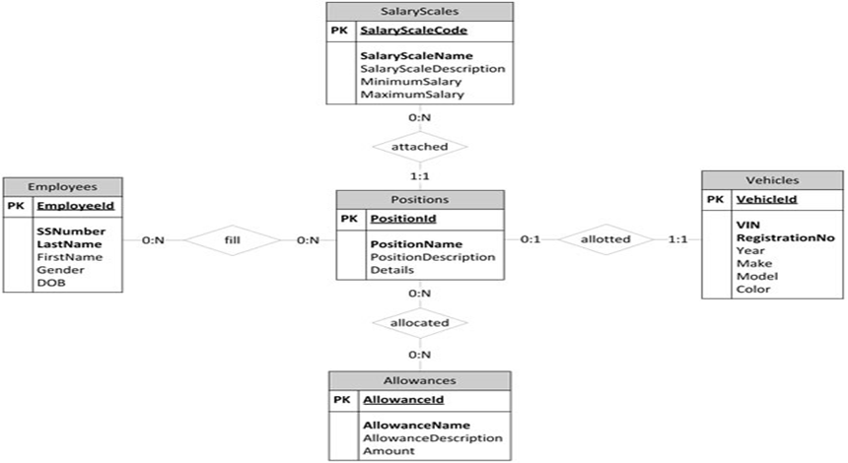

Conclusion:

